JUST A FRIENDLY REMINDER TO ALL STUDENTS ENTERING KINDERGARTEN
FOR THE 2022-2023 SCHOOL YEAR
It is time for Kindergarten Enrollment. Enrollment is MANDATORY for Kindergarten students enrolling for the 2022-2023 school year. Enrollment for Kindergarten will be SATURDAY, March 26, from 8:00 a.m. to 4:00 p.m. Your child must be 5 before August 1, 2022, to be eligible for Kindergarten.
Please EMAIL Mrs. Kellyn Robinson to schedule times for your child to attend this screening. Please include the following in your email:
- Your name and a working phone number (it is important we have a contact number)
- Child’s name, gender, and date of birth
- Indicate if your child is currently in daycare or a preschool program
- Top three times you prefer (Scheduled in hour increments)
- An easy way to get you the enrollment packet to be filled out PRIOR to screenings
Mrs. Robinson can be reached at krobinson@putnamcountyr1.net. If you are unable to email please feel free to call 660-947-3361 ext. 333. You may need to leave a voicemail, but calls and emails will be responded to within 24 hours Monday-Friday (weekends will vary). If you do not hear back, please reach out again to make sure the email/call went through.

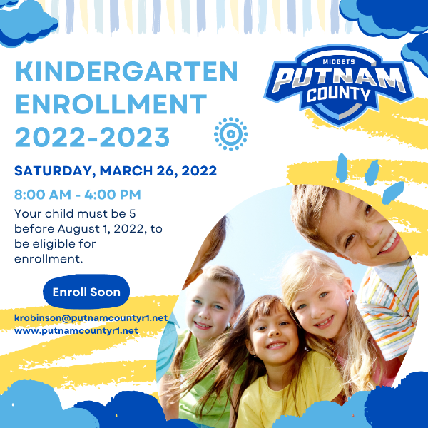

**IF WE DO NOT GET MORE KIDS SIGNED UP BY MARCH 18th Kindergarten Enrollment will be CANCELED for 3/26/22 and other arrangements will have to be made. PLEASE MAKE SUIRE TO SIGN YOUR CHILD UP BY MARCH 18th!**

