Lead Testing Initial Test Results
On August 4th we received the results from the first round of lead testing. In accordance with statute, these results are being communicated to parents and staff via written notification within seven business days.
- Total test points sampled—114
- Total samples with lead detected—42 (37%)
- Total samples with lead levels above the action level of 5ppb—25 (22%)
- Two drinking fountains tested above 5ppb. They are located by Room El-22, and MS-9. Three bottle filler stations tested above 5ppb, by room EL-20, MS-9, and the cafeteria. Three of the four hand sprayers in the kitchen tested above 5ppb. The hand sink in the concession stand and the SOAR building also are above the action limit of 5ppb. All other actionable sample results are from hand sinks and showers.
Immediate actions:
In accordance with guidance from the EPA, the affected faucets or outlets should have signage placed to indicate it is non-potable, not for drinking, or washing dishes. This signage can be temporary since testing is still in progress to localize the source of lead contaminants.
Next steps:

Follow up flush samples will be collected per EPA and DHSS testing guidelines.
Health:
Putnam County Health Dept.
103 N 18th Street,
PO Box 354 Unionville,
MO 63565
CALL: 660.947.2429
FAX: 660.947.3870
Additional information and resources on the health effects of lead contamination are available here:
https://www.epa.gov/ground-water-and-drinking-water/basic-information-about-lead-drinking-water#health
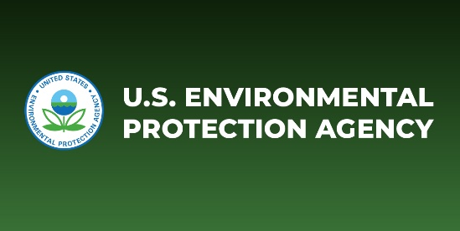 | Basic Information about Lead in Drinking Water | US EPA  Questions and answers about lead in drinking water -- health effects, EPA regulations etc.  www.epa.gov
Lab report and flush sampling plan are available on the school website.
Testing criteria:
Each sample was tested for total lead content which includes dissolved and particulate. The elevated level is defined as a level of lead ≥ 5pbb. Sampling was conducted per EPA test guidelines by initial draw after stagnation (periods of non-use that exceed eight hours). This manner of testing is the first step in localization and is paired with follow-up flush testing to further localize the source of any elevated levels.
Explanation of results:

114 test samples were submitted for testing. 68 were returned with detectable levels.
25 initial draw samples tested ≥ 5pbb total lead. See the follow-up flush plan below for required testing.
Remediation:
These are efforts to mitigate and correct the levels of lead to which children and staff are exposed: The remediation plan will be posted when follow-up flush testing results are received and fiduciary constraints as well as maintenance availability have been considered.

FOLLOW UP FLUSH PLAN FOR Putnam County R-1

Flush Point Test Plan
PTM01-HS29-FBCH-SH FF-001
PTM01-HS29-FBCH-HS FF-002
PTM01-HS30-BBCH-HS FF-003
PTM01-GLKR-HS32-SH1 FF-004
PTM01-GLKR-HS32-SH2 FF-005
PTM01-GLKR-HS32-SH3 FF-006
PTM01-GLKR-HS32-SH4 FF-007
PTM01-GLKR-HS32-SH5 FF-008
PTM01-HS28-FACS-FP4-SC FF-009
PTM01-HS28-FACS-FP4-SC FF-010
PTM01-KITCH-SC1 FF-011
PTM01-KITCH-SC2 FF-012
PTM01-KITCH-SC3 FF-013
PTM01-KITCH-IM FF-014
PTM01-MS9-DFL FF-015
PTM01-MS9-DWL FF-016
PTM01-HS22-DF FF-017
PTM01-HS2-DW FF-018
PTM01-EL20-DW FF-019
PTM01-EL23-HS FF-020
PTM01-BSBL-CONC-RRFB FF-021
PTM01-SB-CONC-HS1 FF-022
PTM01-HS34-GLKR-HS FF-023
PTM01-SOAR-HS2 FF-024
PTM01-FB-NTH-LKR-SHL FF-025

